Onboarding & Orientation Travel Job Aid

TRAVEL MEMO

PURPOSE
To request and administratively record an approved roster of personnel who are authorized travel expenses to attend Onboarding and Orientation using the CBA.

Upon release of closed Onboarding and Orientation roster the Travel Memo must be submitted for approval two weeks prior to the next pay period:

- Build Travel Memo by listing all Onboarding Students requiring use of CBA funding for flights (and possibly lodging).
- Last Name
- First Name
- Personal Email
- Personal Phone Number
- Travel Mode (Round Trip, One-Way)
- Flight Date (Date of Arrival)
- Send for review by Mission Support Section Chief for signature
- Send signed memo to Financial Management of Payment Services Supervisor
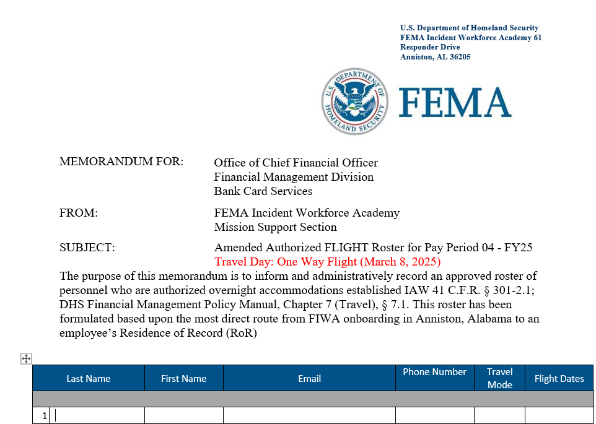

- Update Travel Memo with any corrections/additions (Cancellation, hotel accommodation) and send to the Financial Management of Payment Services Supervisor for approval

- Distribution should include:
  - Payment Services Section
  - FEMA Finance CBA-Recon
  - Workforce Coordination Branch
  - FIWA Mission Support Team

